**Software Requirements Specification For**

**LaundroUs :Laundry Service**

**Ryan Peter (Group Leader)**

**Ta’Yea Cano**

**TianYiMing Jing**

**Sonya Yim**

**October 16, 2023**

**Syracuse University CIS453 M001**

**Table of Contents______________________________________________**

1 Introduction…………………………………………………………………3-4

1.1 Purpose…………………………………………………………………...3

1.2 Scope…………………………………………………………………......3

1.3 Definitions……………………………………………………………......3

1.5 Overview……………………………………………………………........4

2 Overall Description………………………………………………………..5-10

2.1 Product Perspective……………………………………………………....5

2.2 Product Function……………………………………………………..…...6

2.3 Use Case Description………………………………………………....6-10

3 Specific Requirements…………………………………………………....11-17

3.3 System Features……………………………………………………...11-17

**1 Introduction**

**1.1 Purpose**

The purpose of this Software Requirements Specification (SRS) is intended to sketch and outline the software requirements for the customer’s “LaundroUs: Laundry Service.” The intent is to develop a clear guidance of required functionality for the systems developer and Verification & Validation (V&V) for the planning and procedures requirement for the test team to develop the specific demonstration for the customers that the system was to service.

**1.2 Scope**

The main function of the “LaundroUs: Laundry Service” is to provide a platform for clients to save time or earn money through laundry. Clients can either pay for someone to do their laundry at a nearby laundry room or earn money by doing others’ laundry.

1. Laundry Service, includes user interface and mobile application support

2. Create account and modify personal information

3. Make and receive payment

**1.3 Definitions**

1.3.1 SRS: Software Requirements Specification.

1.3.2 V&V: Verification and Validation.

1.3.3 UML: Unified Modeling Language.

1.3.4 SAD: System Architecture Diagram

1.3.5 UCD: Use Case Diagram

1.3.6 SAD: System Architecture Diagram

1.3.7 Runner: Client performing laundry service

1.3.8 Ticket: Job to be performed by Laundry Runner

1.3.9 SLA: Service Level Agreement

**1.5 Overview**

This document follows the recommended format specified in IEEE Std 830-1998 IEEE. Recommended Practice for Software Specifications. For Section 3, the specific template A.5 for organizing information by feature is followed.

**2 Overall Description**

**2.1 Product Perspective**

The LaundroUs is intended to be servicing and used by the customers and the laundry runner. This document specifies capabilities for the two-user group (client and runner) one to receive and the other to provide services in the completion of the laundry service. At the user's end they have capabilities to create, cancel, track, schedule orders and etcetera by using the database. The functioning of the service that is described in this document showcases capabilities that are hosted by a separately defined system. Figure 1 System Block Diagram shows the system overview, using a Unified Modeling Language (UML) System Architecture Diagram.

Figure 1. Laundry Service BDD  
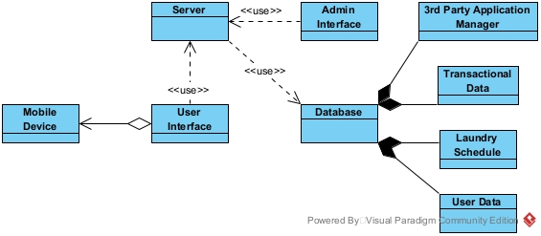

**2.2 Product Function**

The following use case diagram in Figure 2 shows the users (client and runner) of the laundry service and the intended way of how they will interact with the laundry service system.

Figure 2. Laundry Service UCD

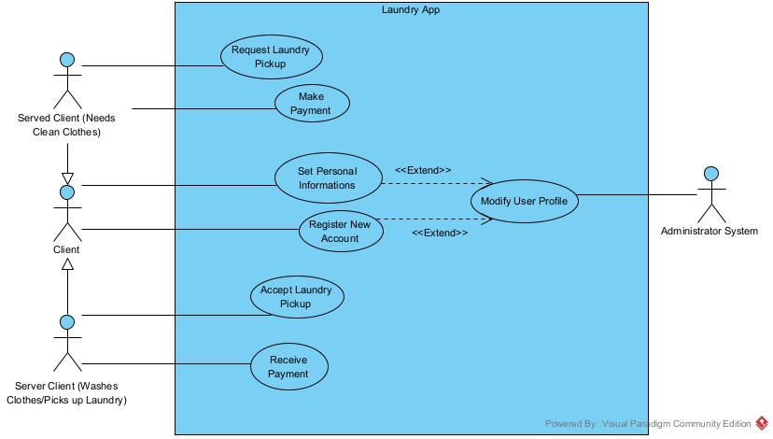

**2.3 Use Case Description**

**2.3.1 Register New Account**

|  |  |
| --- | --- |
| GENERAL CHARACTERISTICS | |
| Intent | Create a User Account |
| Scope | Laundry APP |
| Primary Actor | Client |
| Secondary Actor | None |
| Preconditions | User has a valid email address and/or phone number |
| Assumptions | The user has installed the app and has internet connectivity |
| Trigger | User decides to create a new account |
| Success Post Condition | A new user account is successfully created, and the user can log in with credentials. |
| Failed Post Condition | The account creation fails due to various reasons such as invalid email address, weak password, app error, etc. |

2.3.1.1 Scenario 1: Create User Account

|  |  |
| --- | --- |
| Step | Action |
| Start: | This scenario begins when the user has installed the LaundroUS |
| 1 | The User Interface prompts the new user to select the "Register" option. |
| 2 | The User provides their registration information, including name, email, and |
| 3 | The User selects the "Register" button. |
| 4 | This use case ends when the system validates the provided information. |

**2.3.2 Request Laundry Pickup**

|  |  |
| --- | --- |
| GENERAL CHARACTERISTICS | |
| Intent | Schedule a Laundry Pickup |
| Scope | Laundry APP |
| Primary Actor | Client |
| Secondary Actor | Laundry Runner |
| Preconditions | The client has laundry that needs to be cleaned. |
| Assumptions | The client has installed the app and registered an account. |
| Trigger | Client decides to schedule a laundry pickup. |
| Success Post Condition | A laundry pickup is successfully scheduled, and a runner is assigned. |
| Failed Post Condition | The pickup scheduling fails due to various reasons such as no available runners, app error, etc. |

2.3.2.1 Scenario 3: Schedule a Laundry Pickup

|  |  |
| --- | --- |
| Step | Action |
| Start | This scenario begins when suser is in app and wants to request a laundry pick up |
| 1 | User goes to request pickup section |
| 2 | User selects laundromat they want their clothes to go to |
| 3 | This use case ends when user successfully processes the pickup request and runner is on route |

**2.3.3 Modify User Profile**

|  |  |
| --- | --- |
| GENERAL CHARACTERISTICS | |
| Intent | Modify user information when being asked |
| Scope | Laundry APP |
| Primary Actor | Administrator System |
| Secondary Actor | Client |
| Preconditions | The server and database is functioning |
| Assumptions | The client has installed the laundry app |
| Trigger | A client sends a request to modify his information |
| Success Post Condition | Modification is saved in database and a message is send back to user |
| Failed Post Condition | The modification failed to save, or no message sent to client |

**2.3.4 Accept Laundry Order**

|  |  |
| --- | --- |
| GENERAL CHARACTERISTICS | |
| Intent | Accept a Laundry Order |
| Scope | Laundry APP |
| Primary Actor | Laundry Runner |
| Secondary Actor | Client |
| Preconditions | A new laundry order is available in the runner portal. |
| Assumptions | The runner is available to accept new orders. |
| Trigger | Runner decides to accept a new order. |
| Success Post Condition | The order is successfully accepted, and the runner starts the pickup process. |
| Failed Post Condition | This use case ends when the order acceptance fails due to various reasons such as app error, order already taken by another runner, etc. |

2.3.4.1 Scenario 4: accept laundry order

|  |  |
| --- | --- |
| Step | Action |
| Start | This scenario begins when user is in app and wants to request a laundry pick up |
| 1 | runner goes to accept order section |
| 2 | App notifies users of expected time of completion |
| 3 | User successfully accepts the pickup order and is on route |

**2.3.5 Receive Payment**

|  |  |
| --- | --- |
| GENERAL CHARACTERISTICS | |
| Intent | Receive Payment |
| Scope | Laundry APP |
| Primary Actor | Laundry Runner |
| Secondary Actor | Client |
| Preconditions | The runner is currently completing an order. |
| Assumptions | The runner completes the order. |
| Trigger | The client approves the order completion |
| Success Post Condition | The order is successfully completed, and the runner gets paid. |
| Failed Post Condition | The order is uncomplete and fails due to various reasons such as cancellation of order, bad services, etc. |

**2.3.6 Make Payment**

|  |  |
| --- | --- |
| GENERAL CHARACTERISTICS | |
| Intent | Make Payment |
| Scope | Laundry APP |
| Primary Actor | Client |
| Secondary Actor | Laundry Runner |
| Preconditions | The client requested an order and got an estimate of the charge due to the weight and service. |
| Assumptions | The runner accepts the order and completes it. |
| Trigger | The client received their order. |
| Success Post Condition | The order is successfully delivered and completed, and the client gets charged from the saved payment information. |
| Failed Post Condition | The order acceptance fails due to wrong payment information or unapproval of the payment from the 3rd party. |

**2.3.7 Set Personal Information**

|  |  |
| --- | --- |
| GENERAL CHARACTERISTICS | |
| Intent | Set Personal Information |
| Scope | Laundry APP |
| Primary Actor | Laundry Runner /Client |
| Secondary Actor | None |
| Preconditions | Runner/Client have registered an account for LaundroUs. |
| Assumptions | Runner/Client have successfully created LaundroUs account. |
| Trigger | Runner/Client wanted to use the APP. |
| Success Post Condition | The Runner/Client successfully input all their personal information like bank info, personal info (DOB), address, etc. |
| Failed Post Condition | The Runner/Client fails to input their personal info. |

|  |  |
| --- | --- |
| Step | Action |
| Start | This scenario begins when user is in app and wants to change his personal information |
| 1 | User goes to modify profile and submit changes |
| 2 | Server gets request and modify profile in the database |
| 3 | Server send modification success back to user |
| 4 | This use case ends when user gets and reads the success message |

**3 Specific Requirements**

**3.3 System Features**

3.3.1 The system software supports the Use Cases as described in Use Case Diagram of Figure 2

3.3.1.1 Accept Laundry Pickup

3.3.1.1.1 Introduction/Purpose of Feature

This feature will allow the “runner” (client performing laundry pickup service) to grab an open laundry ticket.

3.3.1.1.2 Stimulus/Response Sequena

3.3.1.1.2 Stimulus/Response Sequence  
**Figure 3 Activity Diagram for Accept Laundry Pickup Use Case**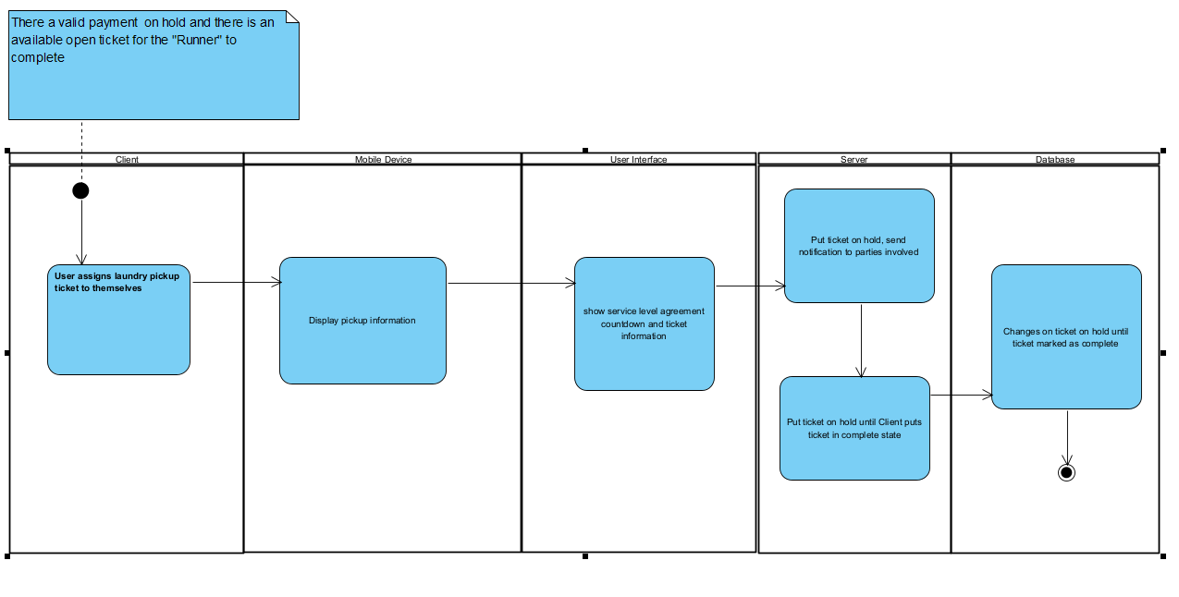

Figure 3.1 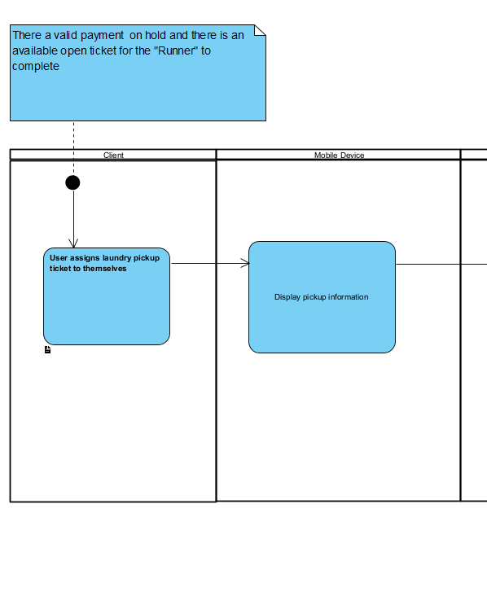F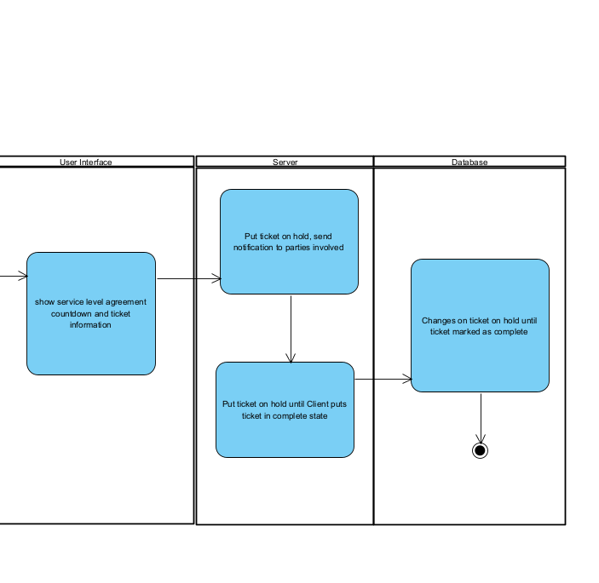  
Figure 3.2 (2nd half of figure 3)  
3.3.1.1.3 Associated Functional Requirements

3.3.1.1.3.1 The payment **shall** be on hold during the entire process

3.3.1.1.3.2 The ticket **shall** not be able to be picked up by other runners during this process  
3.3.1.1.3.3 The runner **shall** be able to see ticket information prior to picking up ticket

3.3.1.1.3.4 The runner **shall** be able to see ticket information while ticket is in progress

3.3.1.1.3.5. The runner **shall** be notified of SLA agreement during ticket progress

3.3.1.2 Set Personal Information

3.3.1.2.1 Introduction/Purpose of Feature

This feature allows clients to modify their personal information.

3.3.1.2.2 Simulus/Response Sequence

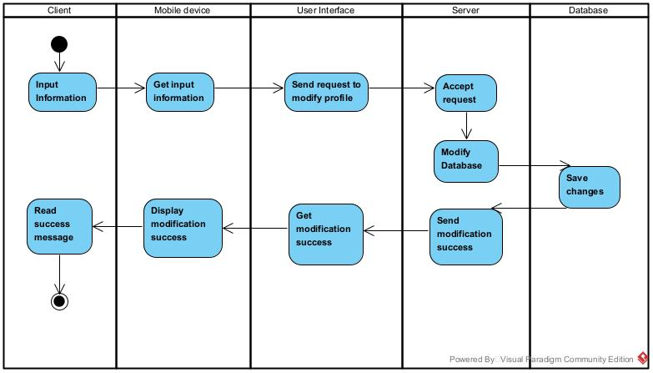

3.3.1.2.3 Associated Functional Requirements

3.3.1.2.3.1 The User Interface shall get input from client through mobile devices.

3.3.1.2.3.2 The User Interface shall send modify pro file request to server.

3.3.1.2.3.3 The Server shall accept requests and modify information in the database.

3.3.1.2.3.4 The database shall save changes and return save success.

3.3.1.2.3.5 The server shall send modification success back to the user interface

3.3.1.2.3.6 The User Interface shall display the success message to client through mobile devices.

3.3.1.3 Request Laundry Pickup

3.3.1.3.1 Introduction/Purpose of Feature

This feature allows clients to to post a laundry pickup request

3.3.1.3.2 Stimulus/Response Sequence  
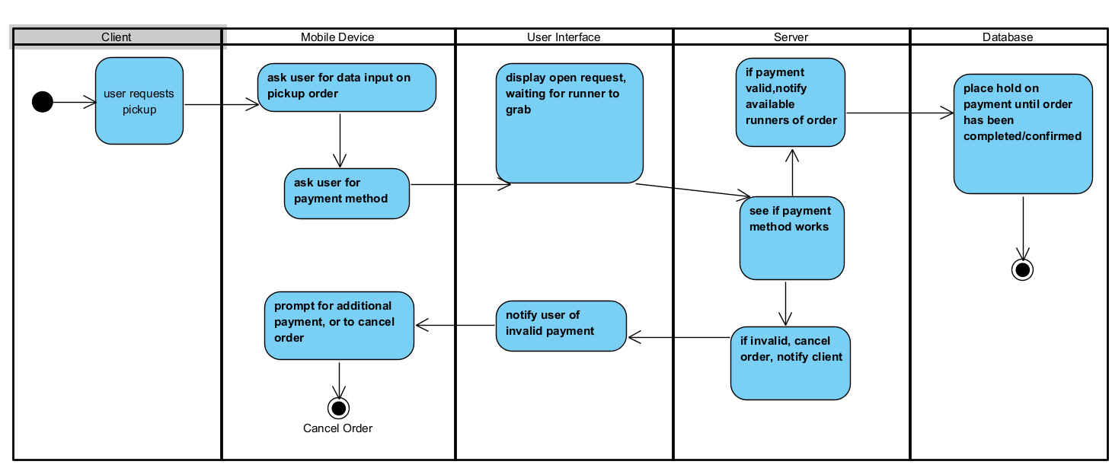3.3.1.3.3 Associated Functions

3.3.1.3.3.1 The user shall be able to request laundry pickups via the mobile app

3.3.1.3.3.2 The app shall ask the user for input on the pickup order

3.3.1.3.3.3 The app shall ask the user for payment method

3.3.1.3.3.4 The system shall verify whether the payment method is valid or not, before notifying users the request is available

3.3.1.3.3.5 The system shall prompt the user for another payment method if the primary method isn’t valid.

3.3.1.3.3.6 The system shall place a hold on ticket information and notify others the ticket is available if the payment method is valid

3.3.1.3.3.7 The system shall allow the user to cancel if they have no other valid payment method

3.3.1.4 Register Account

3.3.1.4.1 Introduction/Purpose of Feature

This feature allows users to create a LaundroUs Account

3.3.1.4.2 Stimulus/Response Sequence

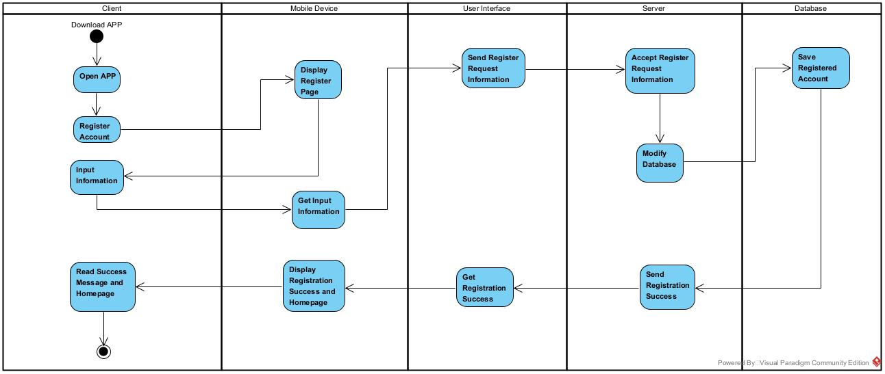

3.3.1.4.3 Associated Functions

3.3.1.4.3.1 The user shall be able to request account registration via the mobile app

3.3.1.4.3.2 The app shall display and ask the user for input of information for registration

3.3.1.4.3.3 The app shall send the registration information to the server

3.3.1.4.3.4 The server shall accept the information and modify the database

3.3.1.4.3.5 The database shall save the registration information of the user

3.3.1.4.3.6 The server shall send back registration is successful

3.3.1.4.3.7 The app shall show the user the registration is successful

3.3.1.4.3.8 The app shall bring users to homepage after account registration successfully